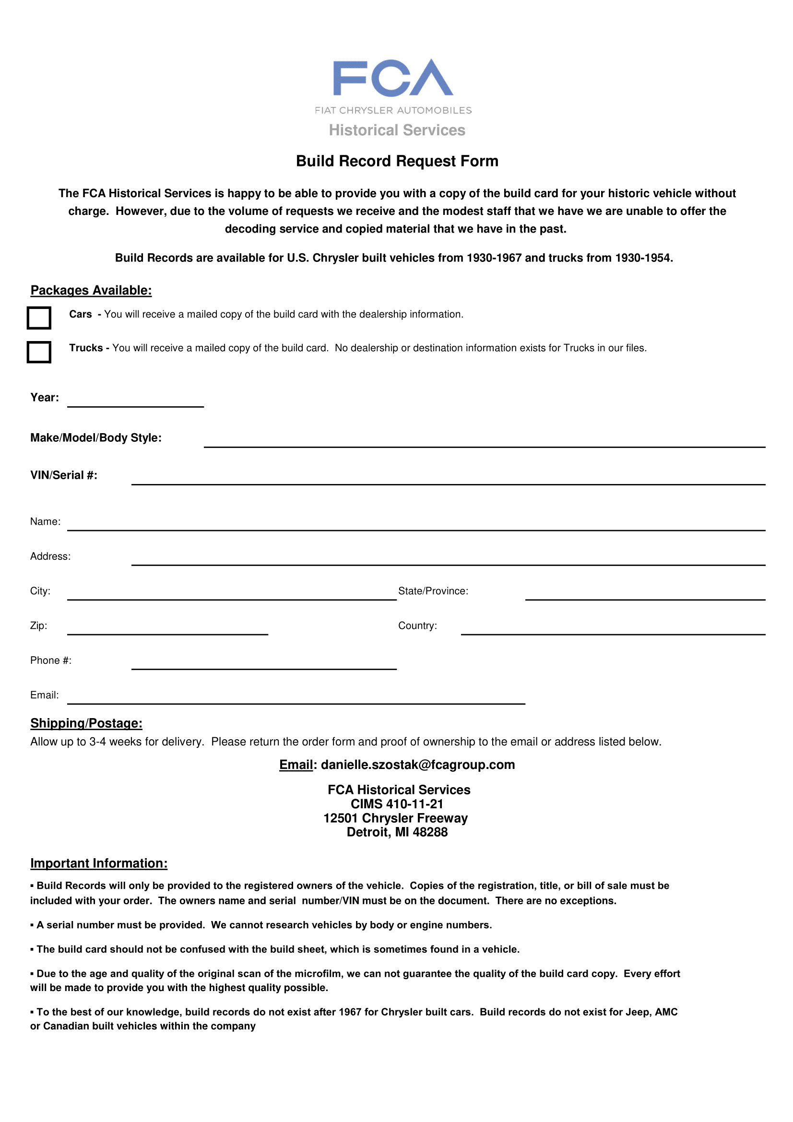
X

X

19##

WC## - U.S.A. Dodge ## ton #x# ,type WC-##

Chassis Number @@@@

NAAM

ADRES

PLAATS PROVINCIE

POSTCODE The Netherlands

(Mobile) +31 6 @@@

@@@@

P.S.
See attached files & images for purchase bill and VIN / Chassis Number / Transport

Attached on next pages… some images…

Attached… some images…

